CTR Monitoring System

- Development Duration
- Total duration: 47 days (extended work due to 8mm operational workload)
  - 40 half days
  - 7 full days

Purpose
To eliminate fake or unverifiable CTR reporting by introducing:
- Time-enforced CTR marking
- Automated activity verification
- Platform-specific validation logic
- Admin-level transparency

Technology Stack

Layer | Technology
Frontend | React.js, Tailwind CSS
Backend | Node.js, Express.js
Database | MongoDB
Authentication | JWT (JSON Web Tokens)
Automation | Selenium
Scheduling | Node-Cron
APIs | Reddit API, Apify (Instagram, Quora)
Tools | Postman, VS Code
Deployment | Github, Render  BHW - Local (Current) / Cloud (Planned)

Database, Hosting, Github all connected with gvp.prakashparmar@gmail.com

System Architecture
The system follows a two-step validation model:
Employee intent + automated verification.

Architecture Flow
Employee → Marks CTR
↓
Task Execution stored
↓
Cron Job runs
↓
Platform API / Scraper
↓
Delta Calculation
↓
CTR Status Generated
↓
Admin Dashboard

Key Design Principle
- Employee marking CTR does not mean completion
- Only cron verification decides final status

Core Features

Employee Features
- Secure login with JWT authentication
- Daily CTR marking per account
- Platform-wise task visibility
- Account management
- Real-time status feedback after verification

Admin Features
- Centralized dashboard
- Platform-wise CTR monitoring
- Retry control and cooldown enforcement
- Cron-verified CTR status
- Partial and suspicious activity detection
- User and account management

Platform-Wise Working
Each platform has custom verification logic, based on what data is realistically available.

6.1 Instagram CTR
Verification Logic
- Baseline snapshot capturedFollower/post delta calculated
- CTR must be marked before verification
- Time-based enforcement prevents post-CTR activity misuse
Possible Status
- Done
- Partial
- Not Done
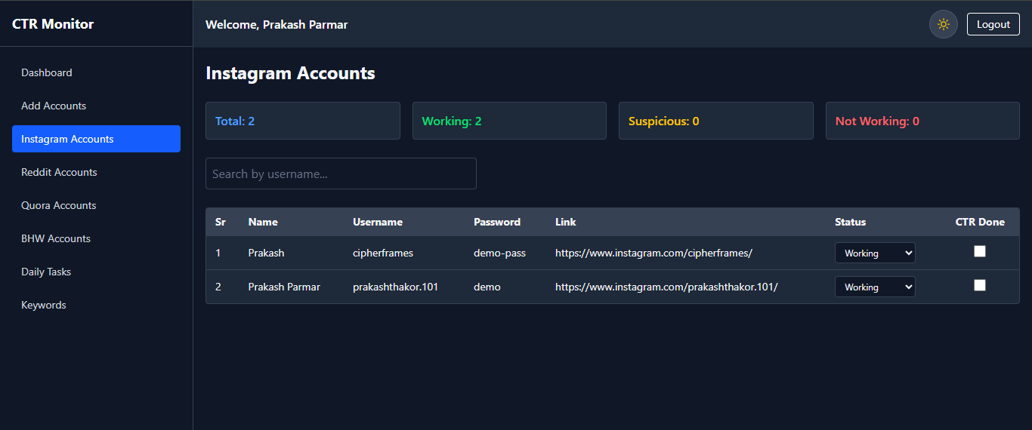
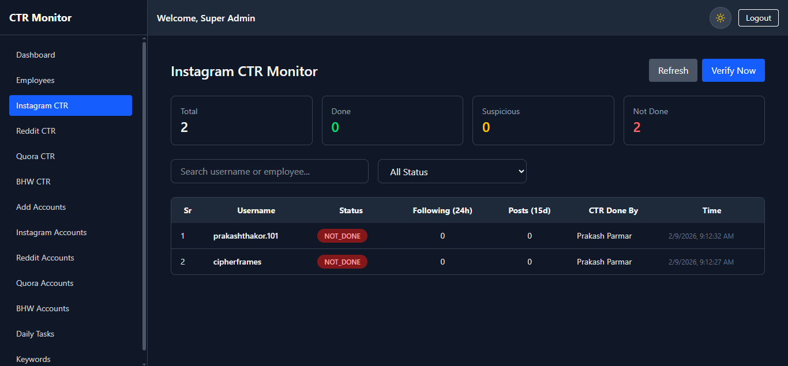

6.2 Reddit CTR
Workflow
- Employee marks CTR (intent only)
- CTR record remains hidden from admin dashboard
- Cron job runs at scheduled time
- Reddit API verifies:
  - Comments in last 24 hours
  - Posts within last 15 days
- Status generated after verification
Key Safeguard
- Admin does not see CTR result until cron finishes
- Prevents false “Not Done” visibility
Possible Status
- Done
- Suspicious
- Not Done
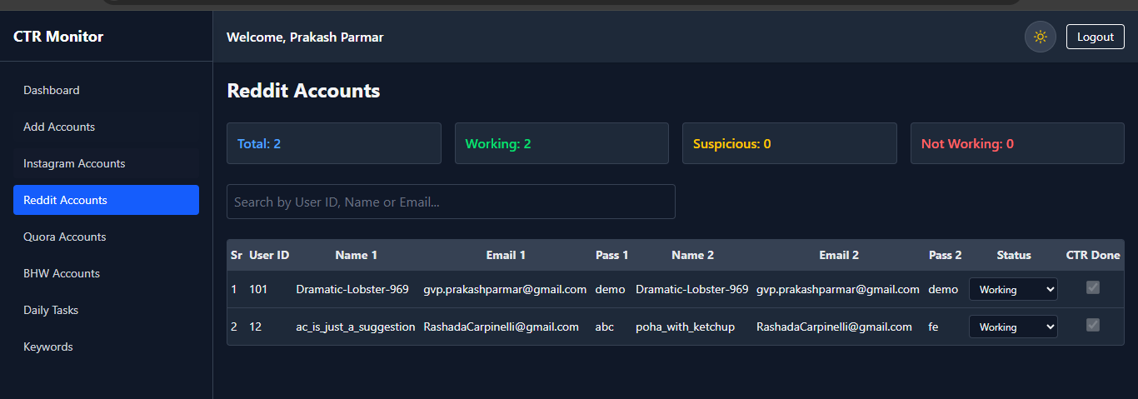
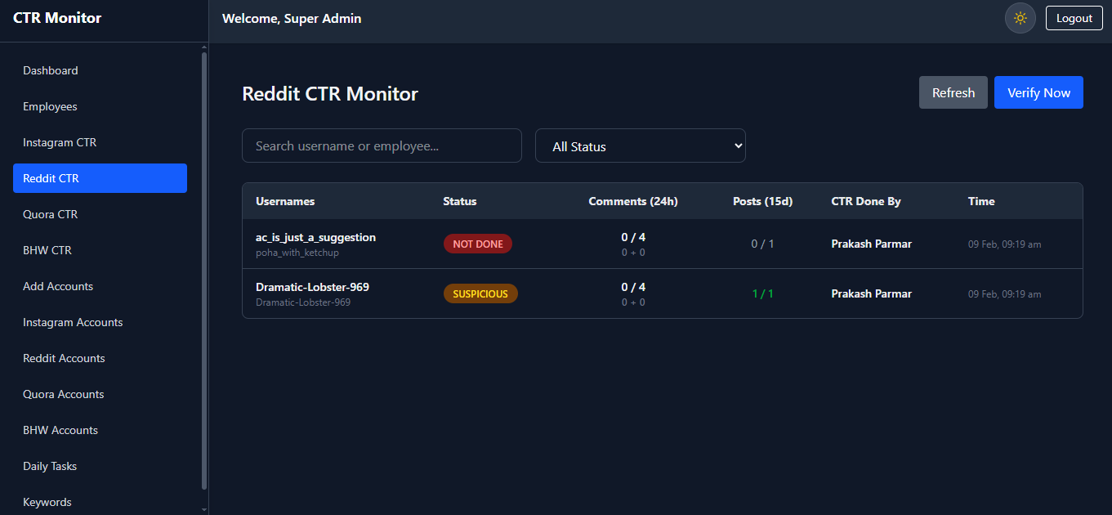

6.3 Quora CTR
Verification Method
- Profile data fetched using Apify
- Metrics tracked:
  - Answers
  - Questions
  - Following
- Baseline comparison ensures correctness
Zero-Data Protection
- If Apify returns all zero values:
  - Data is ignored
  - Database write is skipped
  - Prevents false negatives
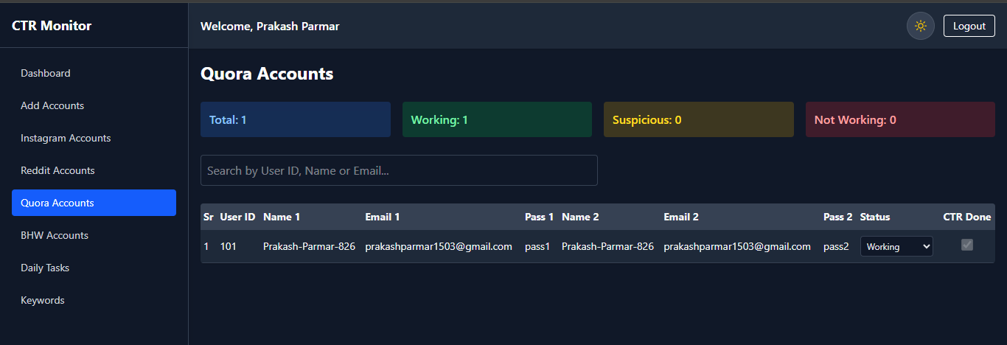
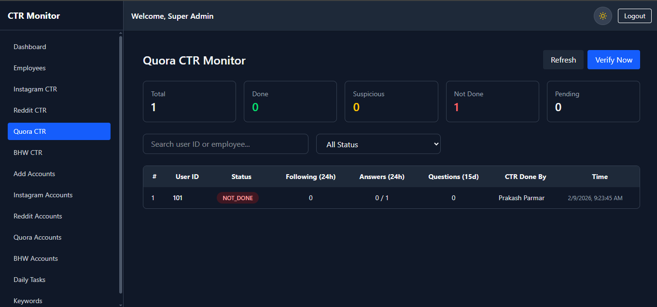

6.4 BlackHatWorld (BHW) CTR
Verification Method
- Selenium-based profile scraping
- Metrics tracked:
  - Message count delta
  - Thread activity (where possible)
  - Reaction score (display only)
Important Design Decision
- Reactions are informational only
- Reactions never decide CTR status
Retry Handling
- Cooldown enforced
- Worker health checked before retry
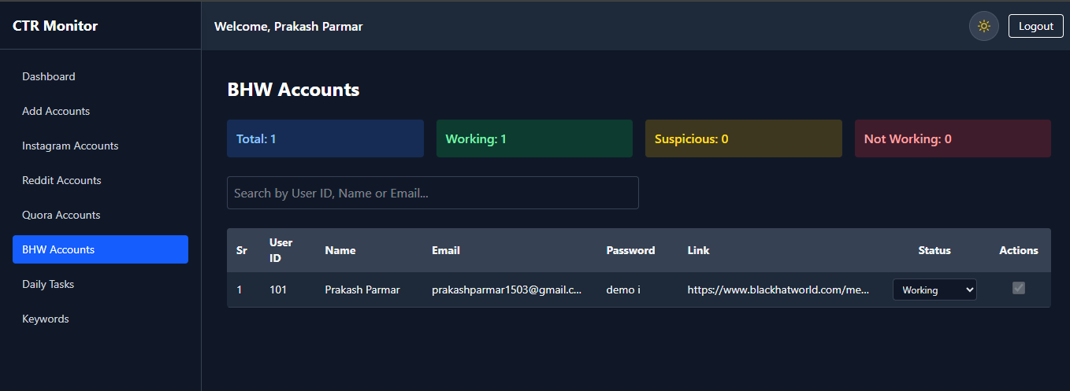
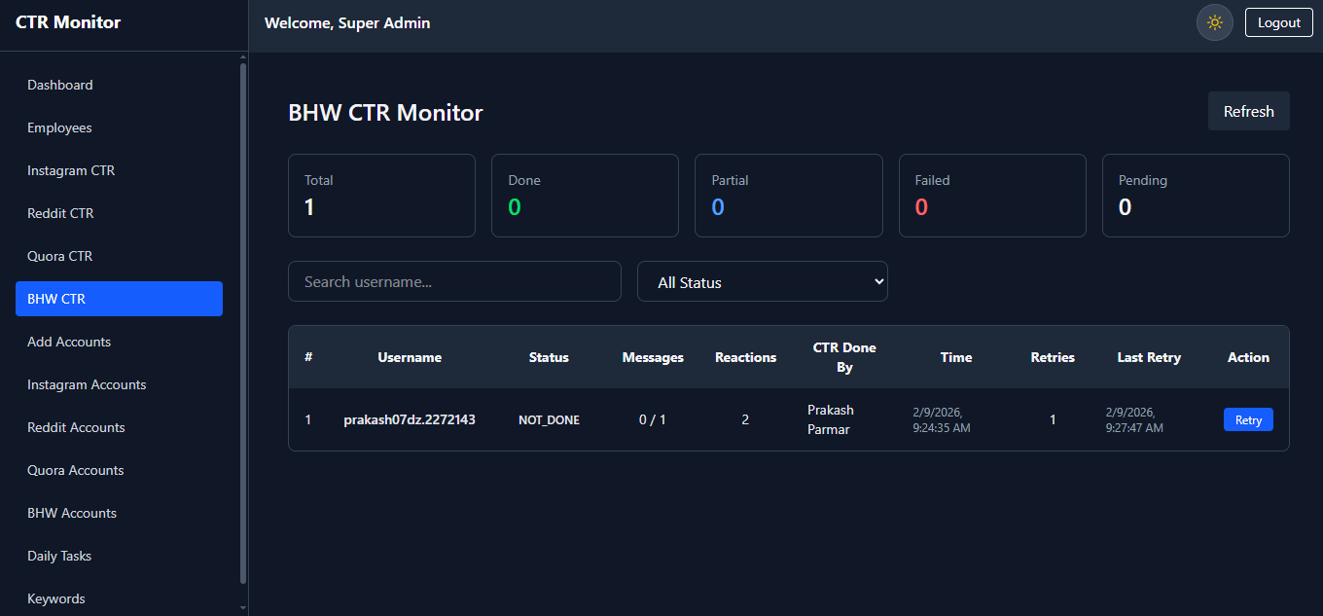

CTR Status Logic

Status | Meaning
Done | All required activity completed
Partial | Some activity detected
Suspicious | Activity detected but below expectation
Not Done | No valid activity
Pending | CTR marked but cron not yet run

Upcoming Project Costs

Database MongoDB (Atlas) – Free tier
Hosting – Render – Free tier

External Services
- Apify
  - Paid scraper usage for Instagram and Quora
  - Cost scales with run frequency

Infrastructure
- BHW Selenium Worker
  - VPS required for stable scraping
  - Dedicated server recommended for scale
These costs are planned for future deployment, not required during initial development.

Future Enhancements

Error Handling & Schema Validation
- Centralized error handling
- Strict MongoDB schema validation
- Prevents invalid writes and silent failures
Why Necessary
- Improves system stability
- Easier debugging and maintenance

Database Optimization
- Automatic deletion of old CTR records
- Retain only:
  - Recent daily records
  - Last 15 days for post validation
Why Necessary
- Reduces database size
- Controls cloud hosting costs
- Improves query performance

Testing (Optional)

Unit Testing
- Jest
- Validate:
  - Controllers
  - Status calculation logic
  - Utility functions

End-to-End Testing
- Cypress
- Validate:
  - Login flow
  - CTR marking
  - Admin dashboard behavior

Live URL - https://gvp-ctrmanager.onrender.com
Admin Credentials (Temp) – username - admin
Password – admin123

